**GLOBAL NATURAL DISASTERS IMPACT ANALYSIS FOR THE YEAR 2024**

**INTRODUCTION**

This report analyzes global natural disasters in 2024, focusing on disaster type, location, magnitude, fatalities, and economic losses. It explores how these factors interact to reveal global disaster trends and impacts. The analysis identifies the most disaster-prone countries and the costliest disaster types. Insights from the findings aim to inform preparedness, response, and mitigation strategies. The overarching goal is to reduce human and economic losses while enhancing global disaster resilience.

**PRE-ANALYSIS BOARD**

**Project Split**

**Category 1: Independent Variables**

* Disaster Type
* Location

**Category 2: Dependent Variables**

* Magnitude
* Fatalities
* Economic Loss ($)

**Potential Analysis/Questions**

1. How do disaster types vary by magnitude?
2. How do fatalities differ across disaster types?
3. What is the economic loss associated with each disaster type?
4. How does magnitude differ across locations?
5. Which locations experience the highest fatalities?
6. Which locations experience the greatest economic loss?

**Industry Type**

**Disaster Management and Emergency Response**

**Story of the Data**

The dataset provides a comprehensive overview of natural disasters that occurred globally in 2024. It captures different types of disasters across various locations, quantifying their severity (magnitude) and associated impacts both human (fatalities) and economic (financial losses). This analysis highlights the human, social, and economic burden of natural disasters and reveals how impacts differ across regions and hazard types.

**Stakeholders**

* Government Disaster Management Agencies
* Emergency Response Teams
* Policy Makers and Regulators
* NGOs and Humanitarian Organizations
* Business Owners and Investors
* Community Residents

**Definition of Success**

For the disaster management industry, **success** is defined as the **minimization of disaster impacts** measured through reduced fatalities, lower economic losses, and improved resilience to future events.

**Potential Insights**

1. Identification of the most disaster-prone regions.
2. Determination of countries with the highest disaster-related fatalities.
3. Assessment of economic losses by country and disaster type.
4. Analysis of disaster magnitude across different locations.
5. Comparison of disaster impacts (fatalities and losses) across locations and disaster types.
6. Evaluation of the relationship between disaster magnitude and fatalities.
7. Evaluation of the relationship between disaster magnitude and economic loss.
8. Identification of high-impact periods for disaster preparedness.

**IN-ANALYSIS BOARD**

**Analysis: Disaster Fatalities over Time**

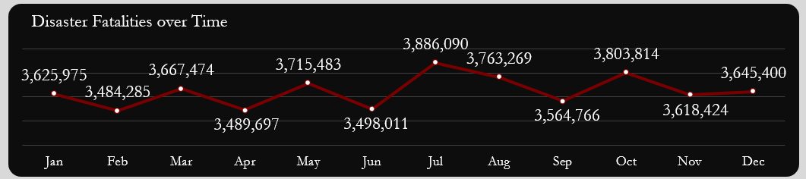

**Observations**

1. Monthly fatalities range between 3.48M and 3.89M.
2. February records the lowest fatalities (3.48M), followed by April (3.49M) and June (3.50M).
3. July records the highest fatalities (3.89M), followed by October (3.8M) and August (3.7M).
4. Fatalities remain relatively stable in Q1 (3.6M–3.67M).
5. Slight decline in Q2 (3.49M average).
6. Sharp peak in Q3 (July–August).
7. Q4 fatalities fluctuate between 3.6M–3.8M.

**Insights**

* Fatalities fluctuate seasonally, indicating that disaster occurrence or severity varies across months.
* The significant peaks in July and October suggest seasonal drivers, possibly linked to climatic or environmental cycles.
* The narrow range of fatalities across months shows that disasters occur consistently throughout the year, not confined to one season.
* The stability in Q1 followed by a sharp rise in Q3 implies mid-year environmental or meteorological shifts may influence disaster severity.
* Persistent high monthly fatalities point to globally sustained disaster exposure rather than isolated regional events.

**Analysis: Disaster Fatalities by Location**

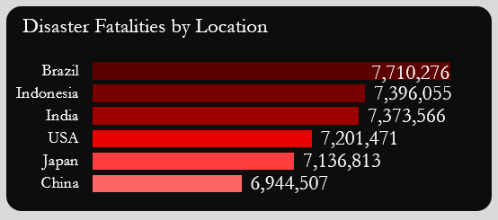

**Observations**

1. Brazil records the highest fatalities (7.71M).
2. Fatalities across countries range between 6.94M (China) and 7.71M (Brazil).
3. Top three countries: Brazil (7.71M), Indonesia (7.40M), and India (7.37M).
4. China records the lowest fatalities (~10% lower than Brazil).
5. Fatal impacts are global and not region-specific.

**Insights**

1. The small variation in fatalities among countries (6.94M–7.71M) suggests disasters have a widespread global impact rather than regional concentration.
2. Brazil’s leading fatalities indicate higher disaster exposure or population vulnerability.
3. Similar fatality levels in Asia and South America show that both developed and developing regions face comparable disaster risks.
4. China’s relatively lower fatalities despite high disaster frequency may reflect stronger response capacity or better infrastructure.
5. Cross-continental uniformity in high fatality counts indicates shared global vulnerability patterns.

**Analysis: Disaster Type by Economic Loss**

**Observations**

1. Earthquakes caused the largest losses ($896B), followed closely by floods ($895B).
2. Tornadoes ($889B), wildfires ($879B), and hurricanes ($866B) follow closely behind.
3. Economic losses are fairly evenly distributed, with a narrow gap of $30B across disaster types.

**Insights:**

1. The close economic loss figures across disaster types suggest that all hazards contribute almost equally to total global losses.
2. Earthquakes and floods drive the largest share of financial damages, confirming their dual role as both frequent and high-impact hazards.
3. The narrow loss range implies that mitigation gaps exist across all disaster types, not just one.
4. High losses from tornadoes and wildfires reflect growing exposure of urban and rural economies to climate-related hazards.
5. Economic impacts are relatively evenly distributed, highlighting that no single hazard dominates global financial risk.

**Analysis: Economic Loss by Location**

**Observations**

1. Brazil recorded the highest economic loss ($767.13B).
2. USA recorded the lowest ($722.86B), though differences among countries are minimal (~6%).
3. Total annual loss across all six countries = **$4.43 trillion**.
4. Economic impacts are widespread across continents.

**Insights**

1. The minimal difference in losses across countries (about 6%) shows that economic exposure to disasters is universally high.
2. Brazil’s top losses correspond with its high fatality count, suggesting that high-impact disasters there affect both life and economy.
3. The USA’s lowest loss, though still substantial, may reflect stronger resilience or insurance systems.
4. Asia’s concentration of mid-to-high losses demonstrates that the region bears a major share of global disaster costs.
5. The $4.43 trillion total loss underscores the global economic burden of natural disasters within a single year.

**Analysis: Disaster Type by Magnitude**

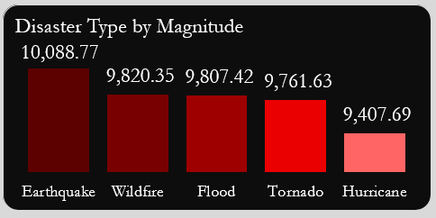

**Observations**

1. Earthquakes have the highest average magnitude (10,088.77).
2. Wildfires (9,820.35) and floods (9,807.42) follow closely.
3. Tornadoes (9,761.63) and hurricanes (9,407.69) are slightly lower.

**Insights**

1. All disaster types exhibit high magnitudes, indicating that 2024 was marked by globally severe events.
2. Earthquakes lead in magnitude, reinforcing their reputation as the most intense natural hazard.
3. Wildfires and floods show near-equal magnitude, suggesting similar destructive capacity despite differing mechanisms.
4. The small magnitude gap between the highest and lowest types points to overall intensification of global disasters.
5. Disaster severity levels are converging, implying that non-traditional hazards (e.g., wildfires) are becoming as strong as classic ones like earthquakes.

**Analysis: Disaster Occurrence per Country**

**Observations**

1. Brazil experienced the highest number of disasters (1,743).
2. China recorded the fewest (1,637).
3. Frequency of disasters is relatively similar across all countries.

**Insights :**

1. The close frequency range (1,637–1,743 events) shows that all countries experienced similar disaster occurrence levels.
2. Brazil’s high frequency aligns with its top fatalities, confirming that repeated exposure amplifies mortality risk.
3. China’s lower event count but high fatalities suggests that fewer but more severe disasters occur there.
4. The narrow variation across nations indicates that global environmental and climatic factors drive widespread disaster activity.
5. Frequency distribution consistency implies a shared global hazard environment rather than isolated national phenomena.

**Analysis: Disaster Magnitude by Location**

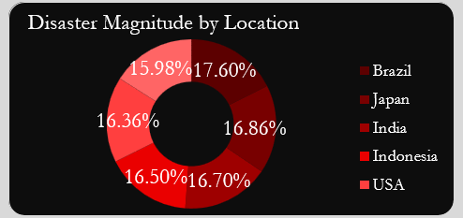

**Observations**

1. Brazil has the highest disaster magnitude share (17.60%).
2. Japan (16.86%) and India (16.70%) follow.
3. China records the lowest (15.98%), though differences are minimal.

**Insights**

1. The near-uniform magnitude percentages (15.98%–17.60%) show that all countries face comparable disaster intensities.
2. Brazil’s highest magnitude share reinforces its position as the most disaster-burdened nation in 2024.
3. Japan and India’s high magnitudes reflect their geographic exposure to seismic and climatic extremes.
4. China’s lower magnitude despite high fatalities indicates secondary factors (e.g., population density, preparedness gaps) influence outcomes.
5. The small spread in magnitudes across countries highlights that disaster severity is a global challenge rather than region-specific.

**POST-ANALYSIS BOARD**

**Post-Analysis Observations**

1. Tornadoes caused the most fatalities and highest losses in Brazil.
2. China’s highest fatalities came from tornadoes; floods caused the most losses.
3. India recorded the most tornado fatalities and wildfire-related economic losses.
4. Indonesia experienced most fatalities from floods and the highest losses from earthquakes.
5. In Japan, hurricanes caused the most fatalities; earthquakes caused the greatest losses.
6. In the USA, wildfires caused the most fatalities and losses.
7. Earthquakes had high year-round fatalities, peaking in Q4.
8. Floods peaked in Indonesia, with China suffering the greatest losses.
9. Hurricanes peaked in October, with India and Indonesia most affected.
10. Tornado fatalities were steady year-round, peaking in July.
11. Wildfire fatalities peaked in May and August, with Indonesia and India most affected.

**Post-Analysis Recommendations**

1. All countries should implement comprehensive disaster preparedness frameworks.
2. Establish regional data-sharing platforms for early warnings.
3. Expand disaster insurance schemes to reduce financial burden.
4. Strengthen public awareness and community-based resilience initiatives.
5. Enhance international cooperation for disaster response and recovery.
6. **Brazil:** Prioritize tornado and earthquake preparedness; strengthen early warnings and enforce resilient building codes.
7. **China:** Focus on flood defense infrastructure and tornado risk forecasting.
8. **India:** Improve tornado response and wildfire management; strengthen insurance and coastal defenses.
9. **Indonesia:** Implement floodplain zoning, enhance coastal defenses, and upgrade earthquake-resistant infrastructure.
10. **Japan:** Invest in forest fire prevention, satellite monitoring, and coastal defense infrastructure.
11. **USA:** Increase funding for wildfire suppression and improve community evacuation plans.
12. Promote global knowledge sharing — e.g., India’s fatality reduction strategies, Indonesia’s tornado resilience practices.
13. Scale up regional collaboration for flood management, data exchange, and early warnings.

**CONCLUSION**

The analysis reveals that natural disasters in 2024 had widespread human and economic impacts, with countries like Brazil, Indonesia, and India experiencing the highest fatalities and losses across multiple disaster types. Tornadoes, floods, and earthquakes emerged as the most destructive hazards, underscoring the urgent need for stronger infrastructure, early-warning systems, and risk financing mechanisms. Overall, enhancing global collaboration, investing in preventive measures, and promoting community resilience are essential to reducing future disaster impacts and strengthening preparedness worldwide.

Data source: Dataset from Kaggle